*MIS 312 Term Paper*

*Ethan Dunzer*

*06/06/2021*

**Table Of Contents**

**1. Introduction**

**2. Analysis Section**

**2.1 -** Use Case’s

**2.2 -** Data Flow

**2.3 -** Entity Relationships

**2.4 -** Human Computer Interface Design

**2.5 -** Structure Design

**3. Design Section**

**3.1 -** Design Elements

**3.2 -** Requirements for Project Design

**4. Conclusion**

**Introduction**

APC needs to expand and capitalize on their current standing in the publishing house market. The goal of APC to increase their business growth by 85% over the next 3 years. This will be achieved by creating better tracking then the current system has to offer, create better relationships with authors, creating a better outreach process to help their appearance to outside authors, and to adjust there “ideal market image” by what is trending.

The new system not only has to upgrade hardware components of their current system but also the functionality of it. In order to streamline their new business processes, they need to shift from a paper-based system to digital in order to keep accurate and better track of their projects. This will help with efficiency, but also information loss which they detailed as a huge problem in their current system. Since all projects will be digital, they can be further organized and categorized by genre and trend to make decisions for the collective easier.

* Submit manuscripts electronically.
* Track manuscripts progress through review process
* Categorize manuscript by genre, subject, and publication type (print or eBook).
* Contracts and their progress
* Pre publish book ISBN assignment.
* Sales from published books
* Author’s sales and publications
* Distribution of published books

APC’s new venture into their system update will increase their value as a business in several key areas. First it will solve their most notable problems that all involve lack of organization through not having a digital ecosystem. By creating a digital environment to take in manuscripts and store information about them as well as authors, trends, and published books there will be more information to look over and analyze for the future. This will not only help them after the initial upgrade, but it will also enable them to be in a better position in the future when they have more expansion or change.

Given APC’s current position in the market as a publishing house with very little overhead they can initiate these changes with the opportunity to bring in more revenue with almost no increase to their current overhead discounting the potential hiring that would give them 11 total employees.

**Analysis**

***2.1 Use Case Diagram***

The idea of this section is to take the broad business processes that are listed in the introduction and turn them into working use cases. This mostly cleans up and combines multiple processes into one use-case, but it also refines the details about how a process will be used in a use-case.

Business processes are a collection of linked tasks that together will create a service or product that the business will then give to the customer. These are normally small activities that works will do on a daily basis to fulfill the companies working needs. Now the level of these processes can differ based on the employee level, but they are always important to completing day to day tasks for an end goal of the business. For example, APC has many business processes that revolve around paperwork, and each of those instances where an employee files, or completes paperwork they have being using a business process.

These cleaned up use-cases will be the solidified system functions that need to take place in creating the final version of this project. Or in other words these are the main needs of the APC team in order for them to function better and achieve their growth goals without overextending themselves with too much system infrastructure.

Every use case is used as a combination of processes that are were brought to my attention by the employee testimonies about their individual roles at APC. These testimonies stated there day to day routine along with known problems that they had during those day-to-day routines. These problems and overall routines were then listed out as processes and then converted into use-cases. Many of the processes that were stated individually by employees could be resolved and updated to the new system through a single use-case. There were multiple instances where this was the case and often, they had to do with the digital record keeping system that will part of the overall system.



***2.2 Data Flow Diagram***

A Data Flow Diagram is a system that is graphically represented. It can contain data flows, processes, sources, destinations, and stores. A Use Case Diagram shows you some of the use cases in your system, some of the actors in your system, and the relationships between them. Since data flows show what the users will be putting into the system and taking out it’s a much more detailed representation of the system.

By creating both the data flow level 0 and level 1 diagrams they are able to convey major tasks that are expected of employees through the new system, and also how they will connect to the different processes. The level 0 data flow diagram shows the employees right way what their main tasks will be and whether or not they are inputting information into the system or taking out information. Level 1 then will allow them to see where that data is going specific to their instance of work. Having this will allow APC’s team to learn their new system and its processes much faster and can clear up miscommunications that would arise if there were no visual representations.

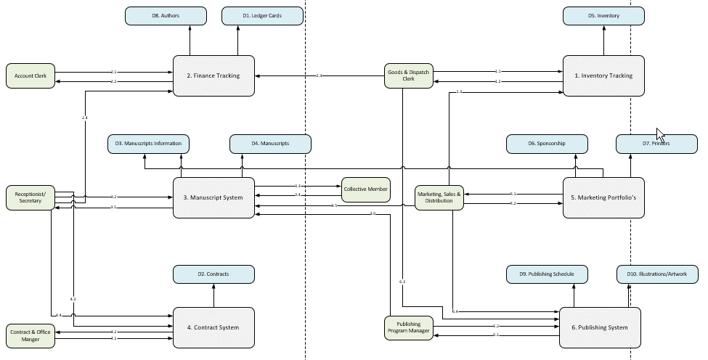

***2.3 Entity Relationship Diagram***

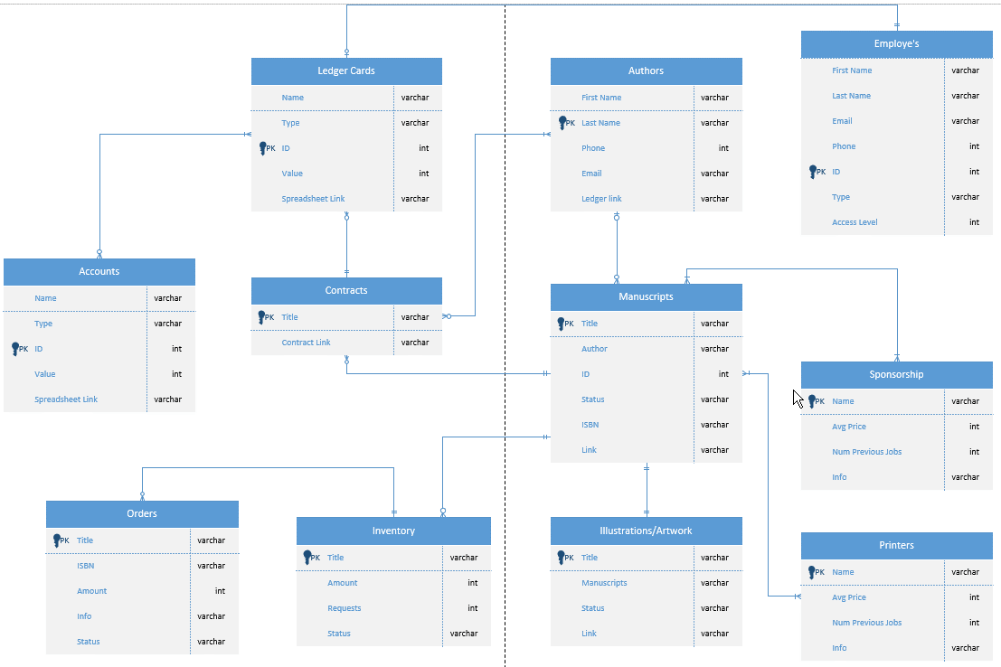

***2.4 Human Computer Interface Design***

***2.5 Structure Design***

As far as the actual chart goes the components are referred to as modules which will represent different components in the system. Each module of the chart is shown in a level format from top to bottom. Level 1 being at the top and level 3 at the bottom. Then there are the subroutines of the system which live under each module. These are typically after level 2 and are organized left to right as in order of occurrence. In between levels 2 and 3 you will see arrows which represent data transfer between each module. The arrows direction represents the direction of the data, and the text will explain the purpose of the transfer.

You will see simple line connections that connect module to module and represent the connection to the overall system parts. There is also a rhombus shape that is used to represent a two-way decision such as true or false, or yes or no. This shape is located under a module where the decision would occur.

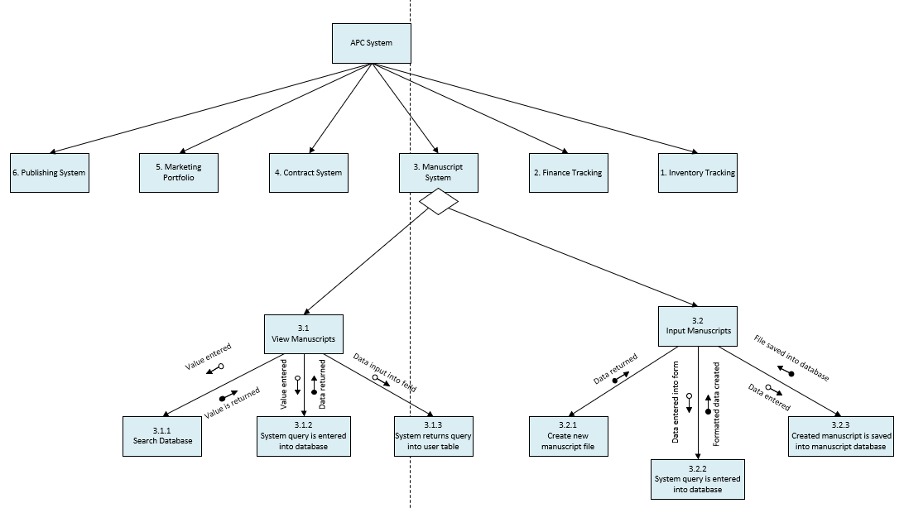

**Design Proposal**

***3.1 Design Elements***

The following high-level business processes will be what the APC system will focus on and strive to accomplish. Overall, these 6 processes are combinations of smaller low-level processes that could be fixed/solved by creating a single process. For example, a single low-level problem that APC was having was lack of information when presenting manuscripts to their Collective Members. In order to solve this the Digital Manuscript system was created where all important documents from other processes will be combined into a single portfolio.

*Digital Finance system:* This will cover all the financing operations for APC through multiple spreadsheets and finance tracking systems. All the important business processes that are taken care of by this system are detailed in the APC requirement log. The key element of this high-level business process is that there will be digital ledger cards instead of the paper ones that APC was originally using. Since the ledger cards are digital, they can be connected to other business processes like the manuscripts in the manuscript system.

*Digital Inventory tracking:* This will cover all the inventory operations for APC through multiple spreadsheets and tracking software. All the important business processes that are taken care of by this system are detailed in the APC requirement log. The key element of this high-level business process is that there will be digital tracking system that can have alerts setup for lack of inventory, or alerts that will be sent to other employee members. This will enable easy work between the inventory workers and the Finance workers because as soon as a receipt is created it can be sent to the finance system.

*Digital Marketing portfolio's:* This will cover all the marketing operations for APC using a business operations system that keeps track of APC clients and there outside sources for marketing, printing, etc. This means that there will be a large list of all identified businesses or people with important and relevant information that APC sees as important. Think of it as a contact system with extra information stored like past interaction whether that be for the authors or for the printing companies that APC has used.

*Digital Contract system:* This will cover all the contract operations for APC through a stored database of all relevant contracts and past/signed contracts. This means there will be a list of pre-made contracts for authors to sign, and then can be adapted for the particular case. Then those contracts will be labeled for that instance and then kept with each revision being saved and tracked back to the database. This database can also be accessed by all employees and then linked to the manuscript system so that contracts for particular manuscripts can be included in the active manuscript.

*Digital Manuscript system:* This will cover all the Manuscript operations for APC through a stored database where all information pertaining to a certain manuscript is stored. So not only will there be the manuscript but there will also be contract information, marketing, inventory, and finance. This will allow other employees to look up particular manuscripts and then view all the important relevant information for that manuscript.

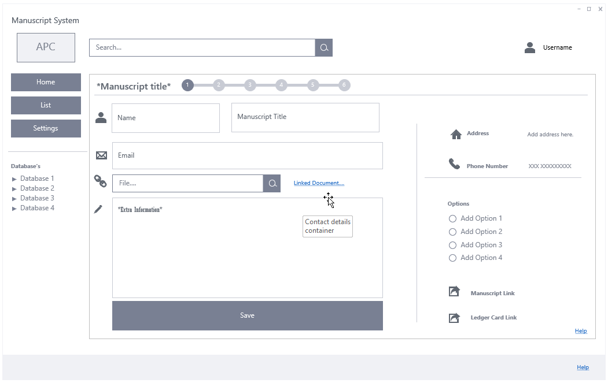

*Digital Publishing system:* This will cover all the Publishing operations for APC using an agile based timetable system which allows for employees to submit their finished tasks and mark as complete. Then when a process of the timetable is complete alerts will be sent to the Publishing team and then the next relevant party so that they can start their next task. This will help in office workflow. To give you a better idea of the system here's an example: The timetable lists an element of "finish contract negotiations with author" when this element is completed the next process needs to take place. So, an alert will be sent to that next elements assignee. This could mean that an alert is then sent to the manager with the contract that has been signed pending approval.

***3.2 Requirements for Project Design***

**Separate Conclusion** for instructor

Give me your thoughts about using the SDLC approach to design an information system for APC. What did you learn? What did you find useful?

Separate reference page if needed

[https://www.reference.com/education/cite-apa-format-8cc5d718592e77f7?qo=contentSimilarQuestions](https://www.reference.com/education/cite-apa-format-8cc5d718592e77f7?qo=contentSimilarQuestions%20)